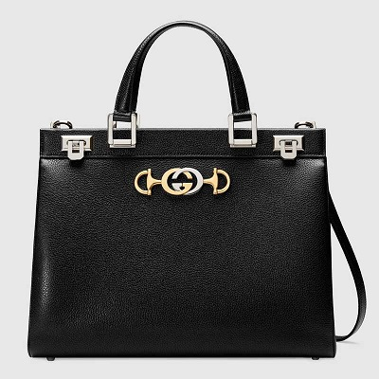

Gucci Zumi grainy leather medium top handle bag

PRODUCT DETAILS

**Shiny gold- and silver-toned hardware • Zumi**

**• Interlocking G Horsebit—inspired by an archival piece, the hardware combines two of**

**the House's most historical motifs in a mix of metals**

**• Protective metal feet at the bottom • Double leather handles with 4.5" drop**

**• Detachable and adjustable leather shoulder strap with 17.3" drop**

**• Three interior gussets • Center zippered compartment • Interior zipper pocket**

**• Double lock closure—lift to open • Made in Italy**